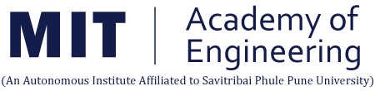

STUDENT INTERNSHIP PROGRAM (SIP) REPORT

Project Title
AI AVATAR CHATBOT

Name of the Institute : Mit Academy Of Engineering

Submitted By:
Name: Arjun Vitthal Mankuskar
Exam Seat No :
PRN No : 202401110038
Class & Branch : CSE(AIML)
School : Computer Science

Under the Guidance of:
Faculty Mentor: Diptee Chikmurge
School Internship Coordinator: AIML

MIT ACADEMY OF ENGINEERING
Alandi (D), Pune – 412105
Table of Contents

Sr. No. | Content | Page No.
1 | Introduction
1.1 | About MITAOE and SIP Overview | 4
1.2 | Project Overview and Internship Details | 4 - 5
2 | Internship Discussion
2.1 | Problem Statement & Objectives | 5 - 8
2.2 | Literature Review / System Study | 8 - 11
2.3 | System Design & Architecture | 12 - 15
2.4 | Implementation Details | 16 - 18
2.5 | Learning Experience | 19 - 20
3 | Conclusion | 21
4 | Bibliography | 22
5 | Plagiarism Report
– | Acknowledgement
– | Certificate (Annexure)

Acknowledgement

I would like to express my sincere gratitude to the MIT Academy of Engineering (MITAOE) for providing me with the opportunity to carry out my Student Internship Program (SIP) during the summer of 2025. This internship has been an invaluable experience that helped me gain both technical knowledge and professional skills.
I extend my heartfelt thanks to my faculty mentor, prof. Deepti ghuse , for their constant guidance, encouragement, and constructive feedback throughout the project. I am equally thankful to the School Internship Coordinator, prof. Anjali Patil, for facilitating the smooth execution of the internship process.
I would also like to acknowledge the support and cooperation of my teammates during the development of the AI Avatar Chatbot project. Working collaboratively with them helped me learn the importance of teamwork, time management, and shared responsibility.
Finally, I am grateful to my family and friends for their encouragement and support during the internship period. Their motivation kept me focused and committed to completing the project successfully.

Name of student
Arjun Vitthal Mankuskar
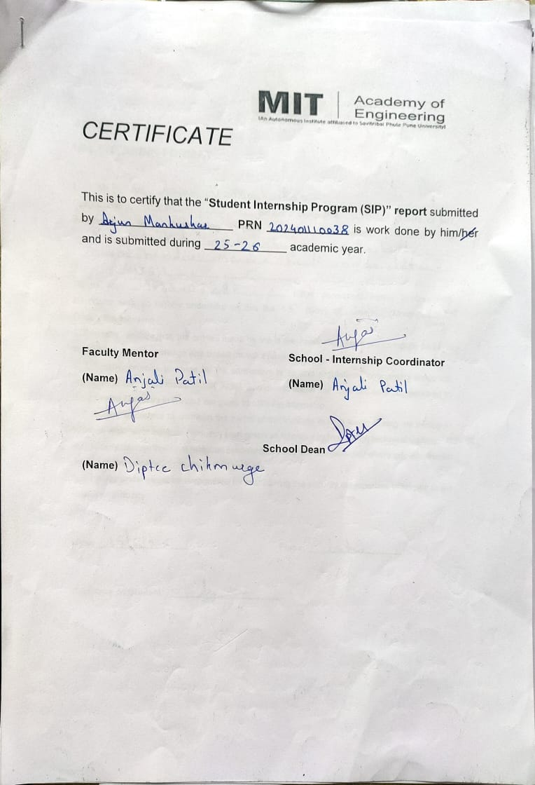Introduction

  - About MITAOE and SIP Overview

The Maharashtra Academy of Engineering and Educational Research (MAEER), Pune, established in 1983, is a reputed educational trust having more than sixty-five institutions imparting quality education from primary to doctoral level in diverse fields. Among its institutions, the MIT Academy of Engineering (MITAOE) was founded in 1999. Today, MITAOE is an autonomous institute affiliated to the Savitribai Phule Pune University (SPPU), approved by the All India Council for Technical Education (AICTE), and accredited with an “A” grade by the National Assessment and Accreditation Council (NAAC). In addition, all undergraduate engineering programs at MITAOE have been accredited by the National Board of Accreditation (NBA).
MITAOE strongly emphasizes not only academic excellence but also practical, skill-based learning through various initiatives. One of the key initiatives is the Student Internship Program (SIP), which provides students with valuable opportunities to acquire hands-on experience, technical exposure, and professional skills. SIP enables students to apply their classroom knowledge in real-world scenarios, thereby enhancing their employability, confidence, and industry-readiness.
The internship for SYBTECH entrants is designed to give students exposure to practical domains right after completing the first year. As part of the SIP for the Academic Year 2025–2026, I undertook my internship project titled “AI Avatar Chatbot for MITAOE”. This project was carried out in a work-from-home mode during the summer vacation, from [Start Date: 15 june 2025] to [End Date: 15 july 2025], under the guidance of prof. Deepti ghuse/chikmurge.

  - Project Overview and Internship Details

The project aimed at developing an AI-powered Avatar Chatbot tailored for MITAOE, with the primary goal of providing interactive, intelligent, and voice-enabled assistance to students regarding college-related queries. The chatbot was designed to respond to questions related to placements, curriculum, NEP pattern, fees, hostel facilities, and amenities. Unlike traditional text-only bots, the proposed system integrates advanced technologies to simulate a conversational avatar with speech and facial expressions, thereby creating a more engaging and user-friendly interface.
The scope of work undertaken during this internship covered multiple stages of development:
- Designing and implementing the Flask backend for handling chatbot requests.
- Connecting to Ollama, a large language model (LLM), for generating contextual responses.

- Exploring FastAPI for database connectivity and efficient request handling.
- Integrating speech-to-text functionality (collaboration with teammate Om) to enable voice input.
- Preparing the text-to-speech pipeline (in collaboration with teammate Arjun) for converting chatbot replies into natural audio.
- Designing the chat interface (frontend) with modern UI/UX practices.
- Adding support for PDF upload and knowledge retrieval as an extended feature.
- Planning the integration of a 3D/2D avatar system with facial expressions (pending as part of future scope).
Through these tasks, the internship provided exposure to a range of domains including Artificial Intelligence, Natural Language Processing (NLP), web development, API integration, and teamwork in a collaborative project environment.

This project aligns with the core objectives of SIP, as it:

- Provided a platform for applying theoretical concepts of AI and software engineering in a practical project.
- Enhanced my technical skills in Flask, FastAPI, APIs, and AI model integration.
- Developed collaborative abilities by coordinating with team members handling Docker, ElevenLabs, and frontend integration.
- Exposed me to real challenges such as system optimization, handling streaming responses, and planning avatar integration.
- Strengthened my professional growth by instilling discipline, responsibility, and problem-solving skills throughout the internship duration.

Thus, the AI Avatar Chatbot project served not only as a technical learning opportunity but also as a comprehensive professional experience. It represents a modern approach to how institutes can leverage AI for student support, while simultaneously preparing us, as budding engineers, for future challenges in the technology-driven world.

2. Internship Discussion

2.1 Problem Statement & Objectives
Problem Statement
In today’s academic environment, students often face challenges in accessing timely and accurate information related to their institute. Queries regarding placements, curriculum structure, NEP pattern, fees, hostel facilities, and various amenities are frequent among students, especially new entrants. Traditionally, students rely on multiple sources such as official websites, faculty members, seniors, or administrative offices to gather this information. However, this approach is often time-consuming, inconsistent, and inefficient.
Additionally, with the growing reliance on digital solutions, there is a strong demand for intelligent, AI-powered systems that can provide instant, reliable, and context-aware assistance. While traditional chatbots exist, most are limited to text-based interactions and static knowledge bases. They fail to deliver a human-like conversational experience, which often reduces engagement and user satisfaction.

To address these gaps, there is a need for an interactive AI-driven solution that combines natural language understanding, voice support, and a visual avatar interface. Such a system can transform the way students interact with institutional resources by offering:

- Real-time, personalized responses to student queries.
- A conversational interface that simulates a human-like experience.
- Voice-based assistance to make the system more accessible and engaging.
- A continuously updatable knowledge base to ensure information remains relevant.

The AI Avatar Chatbot project for MITAOE was conceptualized to fulfill these needs by leveraging Flask, FastAPI, Ollama LLMs, ElevenLabs, and other modern technologies. This solution aims to enhance the overall student experience and make institutional communication faster, smarter, and more interactive.

Project Objectives
The primary objective of the project was to design and develop an AI-powered avatar chatbot for MITAOE that can effectively address student queries and provide a seamless, engaging experience. The specific objectives are:
1. Provide Instant Query Resolution
- Develop a chatbot capable of answering student queries related to placements, curriculum, fees, NEP policies, hostel, and amenities.
- Ensure responses are accurate, contextual, and easy to understand.
2. Integrate AI-Powered Language Understanding
- Utilize Ollama LLM to understand natural language inputs and generate human-like responses.
- Support both text and voice inputs for improved accessibility.
3. Enable Voice Interaction
- Collaborate with the team to integrate speech-to-text (via Om’s module) for converting student voice queries into text.
- Incorporate text-to-speech (via Arjun’s module) to deliver chatbot responses in a natural, conversational voice.
4. Design a Modern, User-Friendly Interface
- Create an intuitive chat interface with a clean and responsive design.
- Include features like chat history, PDF upload, and knowledge retrieval for enhanced functionality.
5. Plan for Avatar Integration (Future Scope)
- Integrate a 2D/3D AI avatar capable of displaying facial expressions to make interactions more human-like.
- Ensure the system architecture supports future integration without major restructuring.
6. Facilitate Continuous Knowledge Updates
- Design the backend to allow easy addition of new data sources and external APIs.
- Enable scalable updates to maintain up-to-date responses as institutional policies evolve.
7. Enhance Collaboration & Deployment Skills
- Gain hands-on experience in team-based development using Git and Docker.
- Explore options for deploying the chatbot in a scalable and secure environment.
Expected Impact on MITAOE Students and Faculty

The successful implementation of the AI Avatar Chatbot is expected to significantly transform the way students and faculty interact with institutional resources. Students will no longer need to depend on multiple platforms, faculty members, or administrative offices for information regarding placements, curriculum, hostel facilities, or academic policies. Instead, they will have a single, unified platform capable of providing accurate, real-time responses in both text and voice formats.
For faculty and administrative staff, this system will reduce repetitive query handling, allowing them to focus more on strategic and academic responsibilities rather than operational communication. Moreover, with planned avatar integration and a continuously updatable knowledge base, the chatbot will serve as a digital assistant for the entire MITAOE community, improving efficiency, accessibility, and engagement across the campus.
This impact aligns perfectly with MITAOE’s vision of promoting innovation-driven learning and integrating cutting-edge technologies into academic processes.

Summary
The project focuses on bridging the information gap between the institute and students by leveraging the latest advancements in AI, NLP, and avatar-based conversational systems. Once fully developed and integrated, the AI Avatar Chatbot will not only save time for students and faculty but also modernize institutional communication through an engaging, interactive experience.

2.2 Literature Review / System Study
Introduction
In recent years, AI-powered conversational systems have gained significant attention due to their potential to automate communication, improve accessibility, and enhance user engagement. Modern chatbots are widely used across domains such as education, healthcare, customer support, e-commerce, and administration. However, despite this technological progress, most chatbot systems lack personalization, interactivity, and real-time multimodal capabilities required in an academic setting like MITAOE.

Existing AI Chatbot Solutions
1. ChatGPT by OpenAI
- Overview:
ChatGPT is one of the most popular conversational AI models based on the GPT architecture. It uses deep learning and transformer-based NLP techniques to generate human-like responses.
- Strengths:
  - High accuracy in understanding context.
  - Supports natural language interaction.
  - Can answer diverse questions effectively.
- Limitations for MITAOE Use:
  - Lacks institution-specific knowledge — cannot directly answer placement, hostel, or fee-related queries.
  - No avatar-based interface or voice integration by default.
  - Dependent on constant internet access and external APIs.
----------------------------------------------------------------------------------------------------------------

2. Google Bard (Gemini)
- Overview:
Google Bard (now Gemini) is an AI-based conversational assistant designed for real-time information retrieval using Google's vast search capabilities.
- Strengths:
  - Access to up-to-date information from the web.
  - Strong summarization and conversational capabilities.
- Limitations for MITAOE Use:
  - Cannot integrate with MITAOE’s internal knowledge base.
  - Does not offer customized domain-specific replies.
  - Lacks visual avatar and dedicated voice assistant integration.
3. IBM Watson Assistant
- Overview:
IBM Watson is widely used for building enterprise-level AI chatbots and virtual assistants.
- Strengths:
  - Highly customizable and can be trained on private datasets.
  - Powerful dialog management and integration features.
- Limitations for MITAOE Use:
  - Requires complex setup and expensive infrastructure.
  - Overkill for small-scale, campus-specific deployment.
-------------------------------------------------------------------------------------------------------------------
4. Microsoft Copilot
- Overview:
Microsoft Copilot integrates conversational AI within productivity apps like Word, Excel, and Teams.
- Strengths:
  - Deep integration into Microsoft ecosystem.
- Limitations for MITAOE Use:
  - Not designed for student-facing institutional chatbots.
  - Limited avatar and interactive capabilities.

Comparison Table of Existing Chatbot Solutions
Feature | ChatGPT | Google Bard | IBM Watson | Microsoft Copilot
Knowledge Base | General | Web-driven | Customizable | Enterprise-only
Voice Support | Limited | Limited | Available | Limited
Avatar Integration | No | No | Possible | No
Institution-Specific | No | No | Yes | No
Ease of Deployment | Easy | Easy | Complex | Limited

From the comparison above, it is evident that existing chatbot solutions are not directly suitable for institutional student support at MITAOE because:
- They lack integration with institute-specific knowledge (placements, fees, NEP policies, etc.).
- Most don’t provide avatar-based interactivity or real-time voice communication.
- They are costly or require complex infrastructure for deployment.
This highlights the need for a custom-built AI Avatar Chatbot specifically designed for MITAOE’s requirements.

Proposed Solution: AI Avatar Chatbot for MITAOE
Our project addresses these gaps by designing a personalized AI-powered chatbot with:
- Institution-specific knowledge continuously updated via PDFs and APIs.
- Flask + FastAPI for efficient backend processing and scalable integration.
- Ollama LLM for context-aware, human-like conversations.
- Speech-to-text (voice input) and text-to-speech (voice output) for accessibility.
- Planned avatar integration to make interactions more engaging and user-friendly.
This combination offers a hybrid approach, balancing advanced conversational AI with a campus-focused design — something no existing solution currently provides.

Summary
This literature review establishes that while existing AI chatbots are highly capable, they are not optimized for academic environments like MITAOE.
Our proposed AI Avatar Chatbot fills this gap by combining voice-based interaction, avatar-driven engagement, and institution-specific knowledge, offering a custom, scalable, and user-friendly solution.

2.3 Systam Design & Architecture
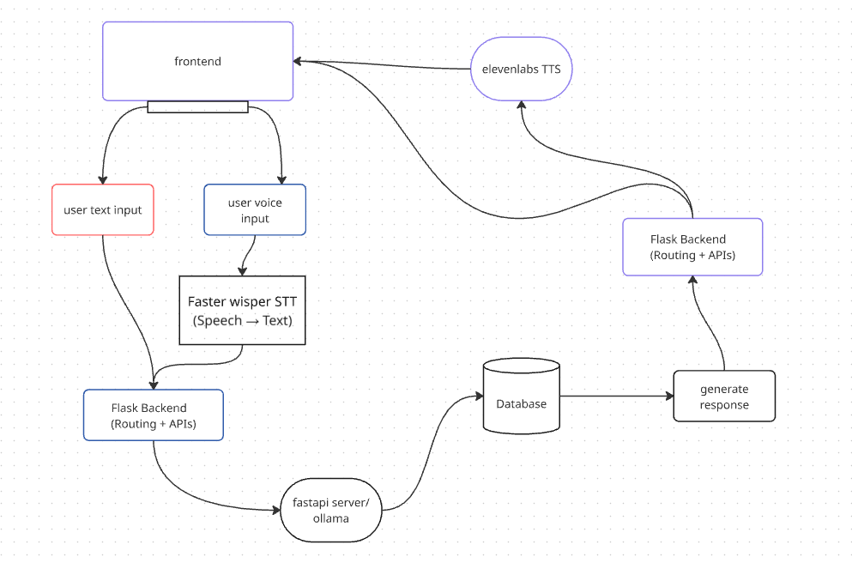

Introduction
The AI Avatar Chatbot for MITAOE was designed using a modular system architecture, where each component is responsible for a specific functionality such as query handling, natural language processing, voice interaction, or data storage. The system follows a client-server model, with the frontend acting as the user interface and the backend handling processing, AI model integration, and database operations.
This modular approach ensures scalability, maintainability, and flexibility, allowing future enhancements such as avatar integration and external API connections without disrupting the existing framework.

Component-Level Design
1. User Interface (Frontend Layer)
- Purpose: Acts as the interaction medium between the student and the chatbot.
- Features:
  - Clean, modern UI with chat bubbles for user queries and bot replies.
  - Support for text input as well as voice input.
  - Option to play bot responses as audio using text-to-speech.
  - Chat history for better usability.
  - PDF Upload Section (for knowledge retrieval from institutional documents).
- Future Expansion: Avatar panel for facial expressions and lip-sync during responses.
-----------------------------------------------------------------------------------------------------------------
2. Flask Backend (Application Layer)
- Purpose: Serves as the integration hub for all modules, routing requests and managing responses.
- Key Responsibilities:
  - Handling incoming text and voice queries from the frontend.
  - Passing requests to Ollama LLM for generating intelligent responses.
  - Communicating with ElevenLabs APIs for speech-to-text (STT) and text-to-speech (TTS).
  - Managing database queries for retrieving PDF/document-based information.
  - Returning structured responses back to the frontend in real-time streaming mode.

3. Ollama LLM (Natural Language Processing Layer)
- Purpose: Core AI brain of the system responsible for understanding queries and generating contextual replies.
- Features:
  - Processes natural language text input.
  - Generates human-like responses tailored to institutional queries.
  - Adaptable for custom fine-tuning with MITAOE-specific datasets.
- Why Ollama?
  - Runs models locally, reducing dependency on cloud-only services.
  - Easy integration with Flask/FastAPI.
  - Cost-effective for academic projects.
-------------------------------------------------------------------------------------------------------------------
4. ElevenLabs Integration (Speech Layer)
- Purpose: Enhances accessibility by supporting voice-based interactions.
- Modules:
  - Speech-to-Text (STT): Converts student voice input into text. (Handled by teammate Om)
  - Text-to-Speech (TTS): Converts chatbot replies into natural human-like speech. (Handled by teammate Arjun)
- Importance: Makes the chatbot more inclusive and user-friendly, especially for students who prefer voice interaction.
- Future Scope: Synchronization with avatar for lip-sync animations.
-------------------------------------------------------------------------------------------------------------------
5. Database / Knowledge Base
- Purpose: Store and retrieve institution-specific knowledge such as:
  - Placement policies
  - Hostel rules
  - NEP guidelines
  - Fees structure
  - Academic curriculum (PDFs)
- Implementation:
  - Initially designed as a PDF retrieval system with query-based search.
  - Scalable for future integration with SQL/NoSQL databases.
- Benefits: Ensures responses are accurate, official, and up-to-date.
-------------------------------------------------------------------------------------------------------------------
6. Avatar Integration (Future Scope)
- Purpose: Add a visual human-like presence to the chatbot.
- Features:
  - 2D/3D avatar with facial expressions.
  - Synchronization with voice output for realistic conversations.
  - Friendly and engaging interface for students.
- Status: Currently in planning phase due to platform selection challenges.
-------------------------------------------------------------------------------------------------------------------
Workflow of the System
Workflow of AI Avatar Chatbot

- Step 1: The user enters a query through text or voice in the chat interface.
- Step 2: If voice input is given, ElevenLabs STT converts speech into text.
- Step 3: The Flask backend receives the input and processes the request.
- Step 4: The query is sent to Ollama LLM for generating a response.
- Step 5: If required, the backend fetches data from the knowledge base or database.
- Step 6: The final text response is generated by Flask.
- Step 7: ElevenLabs TTS converts the text response into voice if needed.
- Step 8: The frontend displays the response in chat and plays audio output.
- Step 9: In future, the avatar will animate the reply for a realistic interaction.

Advantages of the Proposed Architecture
- Scalability: Easy to add new features like API integrations.

- Flexibility: Supports both text and voice input.

- Engagement: Future avatar integration makes it more interactive.

- Reliability: Institution-specific knowledge ensures relevant answers.

- Learning Value: Provides exposure to Flask, FastAPI, APIs, Docker, and AI tools.

2.4 Implementation Details
Introduction
The implementation of the AI Avatar Chatbot was carried out in a modular and collaborative manner, with each team member focusing on different aspects such as backend development, voice integration, Docker setup, and UI design. The project followed a step-by-step approach, starting from backend setup to frontend integration, ensuring that each module was tested individually before being combined into the final system.

Module-Wise Implementation
1. Flask Backend Development
- The chatbot’s core application was developed using Flask.
- Flask handled:
  - Routing of requests between frontend and AI modules.
  - API endpoints for text input, voice input, and response streaming.
  - Managing asynchronous communication for real-time responses.
- Flask was chosen for its simplicity, flexibility, and scalability, which made integration with other services seamless.

2. Integration with Ollama LLM
- Ollama was integrated as the language processing engine.
- Workflow:
  - Input text → Sent to Ollama → Contextual response generated.
  - Responses were designed to be short, clear, and student-focused.
- This provided the NLP backbone, ensuring the chatbot could understand and reply naturally.

3. Speech-to-Text (STT) Module
- Implemented in collaboration with teammate Om.
- Used ElevenLabs STT API to convert student voice queries into text.
- Integrated into the Flask backend via a dedicated route (/transcribe).
- This enabled students to ask questions hands-free using only their voice.

4. Text-to-Speech (TTS) Module
- Developed with the help of teammate Arjun.
- Used ElevenLabs TTS API to convert chatbot responses into natural speech.
- Integrated into Flask as a /speak route.

5. Frontend User Interface
- Designed a clean, modern web UI using HTML, CSS, and JavaScript.
- Features included:
  - Chatbox layout with user and bot messages in bubble format.
  - Floating input bar for typing queries.
  - Voice recording button to capture voice input.
  - Speak button beside responses for TTS playback.
- The frontend also supported real-time streaming of chatbot responses, giving the impression of live typing by the bot.

6. PDF/Knowledge Base Integration
- Added functionality to upload institutional PDFs (like placement policy or fee structure).
- Flask parsed these documents and stored them for query-based retrieval.
- Allowed the chatbot to provide official, document-backed responses.

7. Docker & Deployment Preparation
- One teammate managed Docker setup for containerization.
- Each module (Flask backend, Ollama, ElevenLabs, DB) was planned to run in separate containers.
- This ensured scalability and simplified deployment in real-world scenarios.

8. Avatar Integration (Pending/Future Work)
- Avatar integration is in the planning stage due to platform selection challenges.
- Options explored included 2D/3D avatars with lip-sync using Unity, Unreal Engine, or Web-based solutions.
- This remains as future scope to be integrated later without affecting the current system.

Interface of AI AVTAR CHATBOT

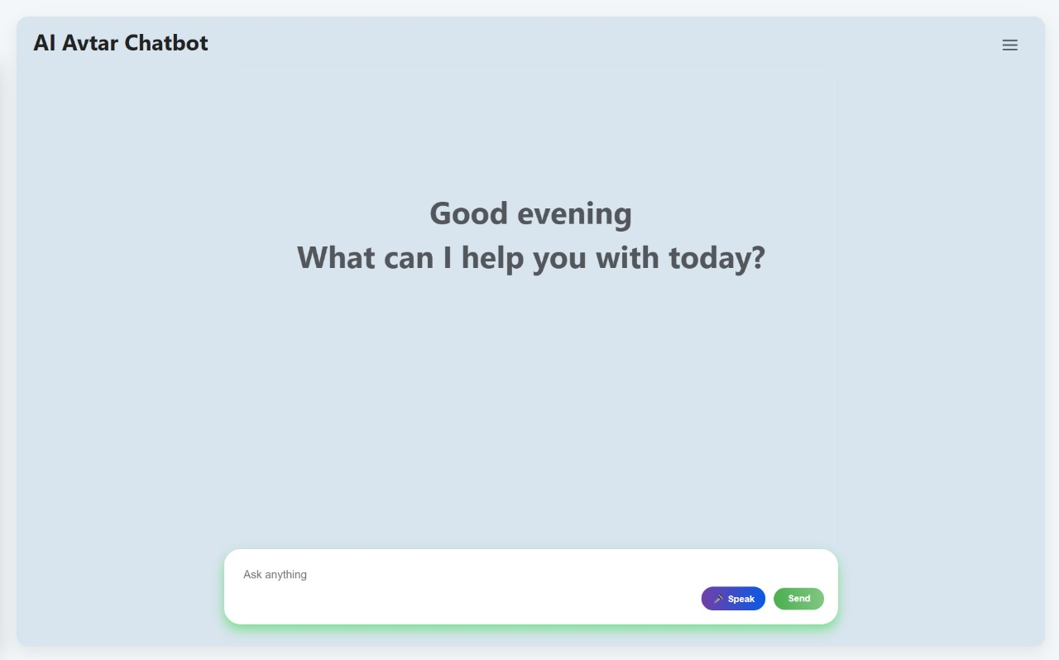

2.5 Learning Experience
Introduction
The Student Internship Program (SIP) was a valuable opportunity to apply theoretical concepts learned during the first year of engineering into a real-world technical project. Through the development of the AI Avatar Chatbot for MITAOE, I gained exposure to a wide range of modern technologies and also developed essential teamwork, communication, and problem-solving skills. This experience has not only strengthened my technical foundation but also prepared me for future academic and professional challenges.
Knowledge Gained
During this internship, I was able to explore and understand several new technologies and frameworks:
- Flask Framework: Learned how to build and structure a web application using Flask, define routes, and integrate APIs.
- FastAPI Exploration: Explored FastAPI for database connectivity and efficient request handling, comparing its performance with Flask.
- Large Language Models (Ollama): Understood how to integrate an LLM into a chatbot and process natural language queries effectively.
- Frontend Development: Enhanced my skills in HTML, CSS, and JavaScript while designing a clean and interactive chatbot UI.
- Speech Technologies: Collaborated with teammates to understand the working of Speech-to-Text (STT) and Text-to-Speech (TTS) modules using ElevenLabs.
- PDF/Knowledge Base Integration: Learned how to connect documents to a chatbot for accurate, institution-specific answers.
-------------------------------------------------------------------------------------------------------------------

Skills Acquired
Apart from technical learning, I also gained several practical and professional skills:
- Team Collaboration: Worked effectively with a group of five members, coordinating responsibilities like STT, TTS, backend, and Docker.
- Problem Solving: Learned to debug issues such as response streaming, frontend alignment, and integration challenges.
- Version Control: Improved my GitHub knowledge for managing shared code, branches, and pull requests.
- Communication: Practiced clear communication during meetings and while dividing tasks among the team.
-------------------------------------------------------------------------------------------------------------------
Challenges Faced
The journey was not without challenges, and overcoming them contributed greatly to my growth:
- The avatar integration could not be completed due to platform compatibility issues, which is planned as future scope.
- Managing real-time streaming responses from Ollama and displaying them smoothly in the UI required multiple trials.
- Frontend alignment issues (floating input, button placement) demanded extra effort in CSS and JavaScript.
- Coordinating among team members remotely during the work-from-home setup required discipline and time management.
-------------------------------------------------------------------------------------------------------------------
Professional Growth and Values
This internship also helped me develop professional values:
- Discipline: Sticking to deadlines and completing modules on time.
- Responsibility: Taking ownership of the Flask backend and ensuring smooth integration.
- Team Spirit: Supporting teammates in STT and TTS integration while focusing on my own tasks.
- Innovation Mindset: Thinking beyond a basic chatbot and planning for avatar-based interaction.

3. Conclusion

The Student Internship Program (SIP) gave me the opportunity to apply my classroom learning to a real-world technical project. Through the development of the AI Avatar Chatbot for MITAOE, I gained both technical skills and professional experience.
The project successfully delivered a chatbot capable of handling text and voice queries, generating context-aware responses using Ollama LLM, and supporting institution-specific answers through a knowledge base. The integration of speech-to-text (STT) and text-to-speech (TTS) modules made the system more accessible, while a modern UI ensured smooth interaction.
Although the avatar integration could not be completed within the timeline, the system has been designed in a modular way, making it possible to add this feature in the future.
This internship not only strengthened my skills in Flask, APIs, and frontend design, but also improved my teamwork, communication, and problem-solving abilities. Overall, the SIP was a holistic learning experience that prepared me for more advanced projects and gave me the confidence to explore innovative solutions in the field of AI.

4. Bibliography
• Flask Documentation. (n.d.). Flask: Web Development Framework in Python. Retrieved from https://flask.palletsprojects.com/

• FastAPI Documentation. (n.d.). FastAPI: Modern, Fast (High-performance), web framework for building APIs with Python. Retrieved from https://fastapi.tiangolo.com/

• Ollama. (2025). Large Language Models for Local Inference. Retrieved from https://ollama.ai/

• ElevenLabs. (2025). AI Speech-to-Text and Text-to-Speech Platform. Retrieved from https://elevenlabs.io/

• MIT Academy of Engineering (MITAOE). (2025). Official Institute Website. Retrieved from https://mitaoe.ac.in/

Flask:
🔗 Official Docs: https://flask.palletsprojects.com
🎥 Crash Course: Corey Schafer Flask
Ollama:
✅ GitHub: https://github.com/ollama/ollama-python
📄 Docs: https://ollama.com/library

